W-15
YEAR 9 SCIENCE
PHYSICAL SCIENCES
REVISION - TEST 1

1. (a) How do the particles move in a transverse wave? Give an example of this wave.

(b) How do the particles move in a longitudinal wave? Give an example of this wave.

(c) Draw a displacement - distance graph to show the following. Make sure you give appropriate scales and labels.

amplitude = 5.00 cm
wavelength = 10.0 cm

2. (a) How would you describe light - what is it?

(b) Does light need a medium (substance) to travel in? How do you know?

3. (a) List the parts of the electromagnetic spectrum in order.

(b) Give a use or characteristic for each part.

4. (a) What are the Laws of Reflection?

(b) Draw a simple diagram to show it.

5. What is the difference between a real image and a virtual image?

Virtual image:

Real image:

6. Complete the following ray diagrams.

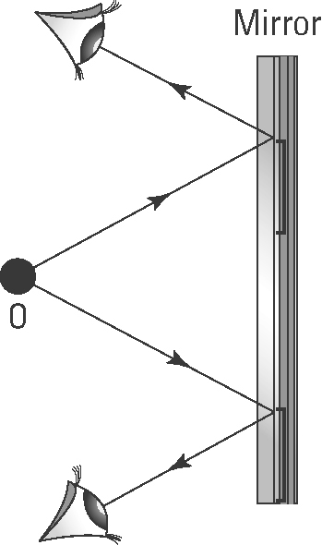

7. Explained how heat is transferred in the following.

(a) A piece of copper wire that is heated at one end.

(b) A pot of warm water that is being heated.

(c) A room with a small gas heater at floor level.

8. Metals have a very high thermal conductivity (able to transfer heat quickly) while gases are very low. Explain this difference.

9. Some very expensive cookware has copper bottoms on all the pots and pans. Suggest a reason for this.

10. Sports people who injure themselves are advised to put ice or a cold pack immediately on the injury to limit any internal bleeding. Why does the ice feel cold on the skin?

11. Radiators on cars, trucks and other engines are painted black and have lots of very fine "fins" which allow the air to pass through. How do these two features make the radiator an efficient cooling device for the water carrying heat away from the engine?

•

•

12. Draw a simple labelled diagram to explain how a sea breeze occurs during the summer.

13. Parents become quite annoyed when one of their children stands in front of the refrigerator with the door open, thinking about what they would like to take from it. The cold air "falls" out of the fridge onto their feet and the motor starts to chill the inside again once the door closes. This costs money in the long run!

Why does the cold air "fall" out?

